EXPERIMENT NO: 13
Determination and plotting of intinsic impedance and phase velocity of various medium Aim:
To determine and plot intrinsic impedance and phase velocity of various medium.

Software required:
• SCILAB version 6.0.1
Program:
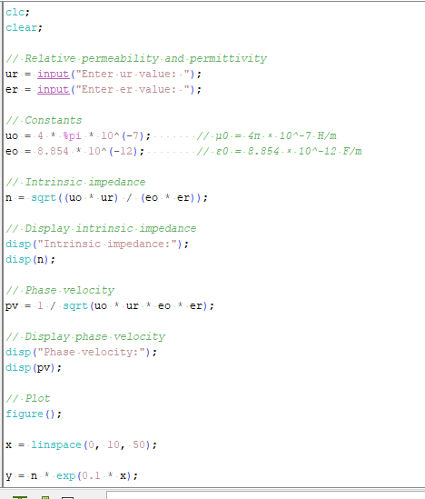
Output :
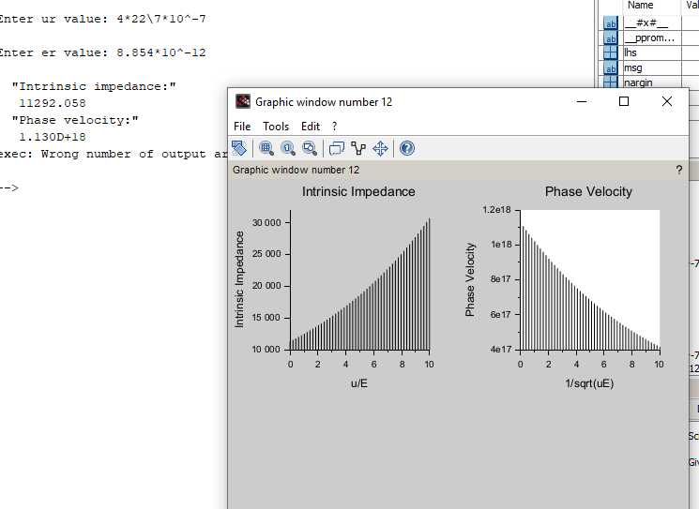

Theoretical calculation:

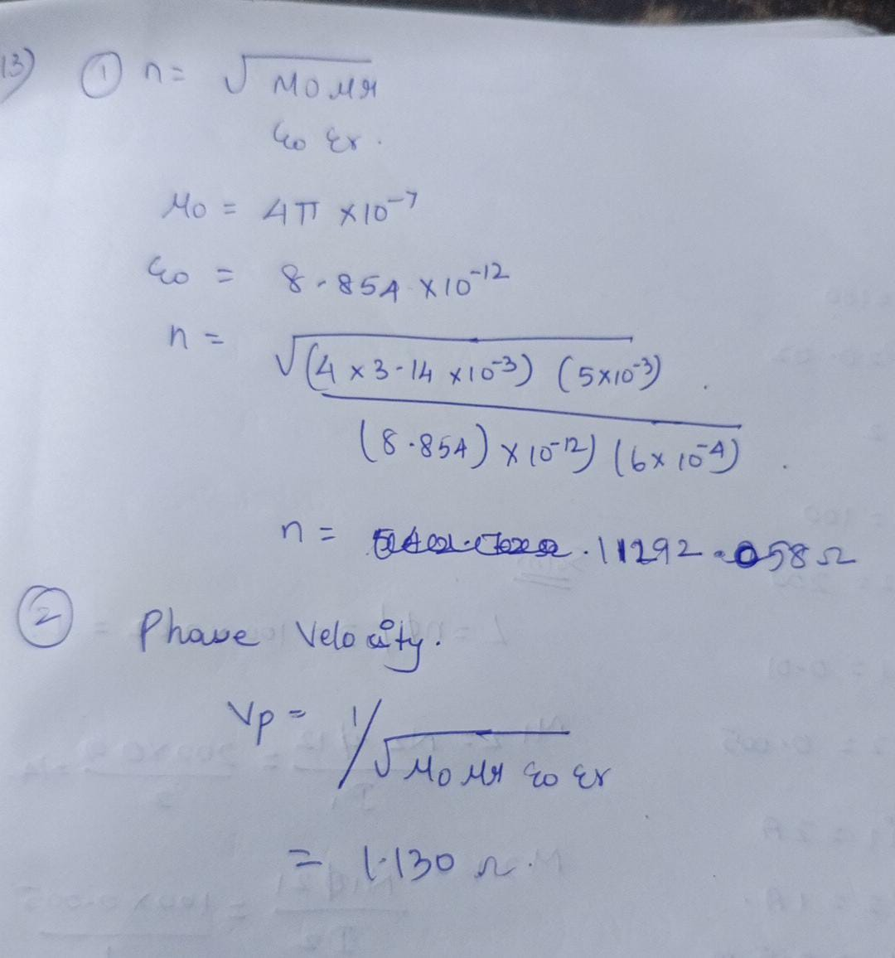
CASE 1
To determine the intrinsic impedance and phase velocity of electromagnetic waves in free space(vacuum).
Program:

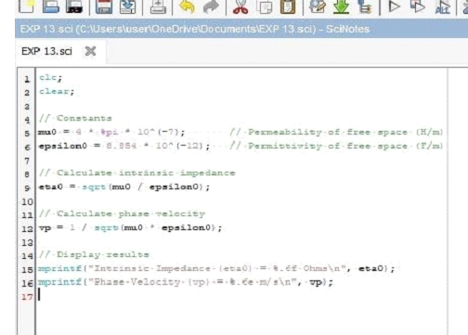
Output :
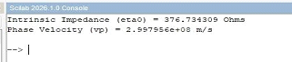
CASE 2
To determine the intrinsic impedance and phase velocity for a wave propagating through a conductive medium like copper.
Program:

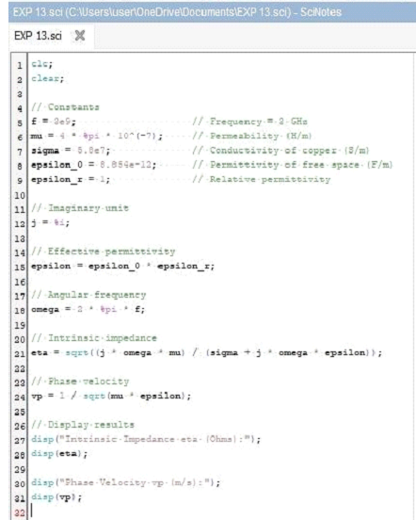
Output :
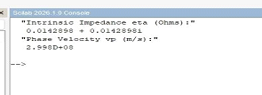
CASE 3
To determine and compare the intrinsic impedance and phase velocity of electromagnetic waves propagating through different media: Vacuum, Air, and Water.
Program:

Output:
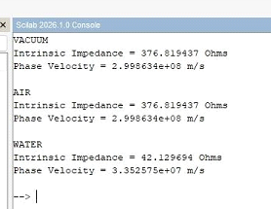
Result:
Thus the determination and plotting of intrinsic and phase velocity is performed and successfully verified in copper.

